Nominees for the Customer and Employee Experience Awards 2026 Announced
Organizations excelling in customer and employee experience in the spotlight
Rotterdam, [date] – The organizations that truly make a difference for their customers and employees have been announced. Integron today reveals the nominees for the Experience Awards 2026. The awards will be presented on June 4 during a festive event, where the winners will be announced.
The Experience Awards are awarded annually to organizations that perform above average in customer and employee experience. The nominations are based on more than 300 studies conducted by Integron in 2025. These assess the extent to which customers and employees would recommend the organization.
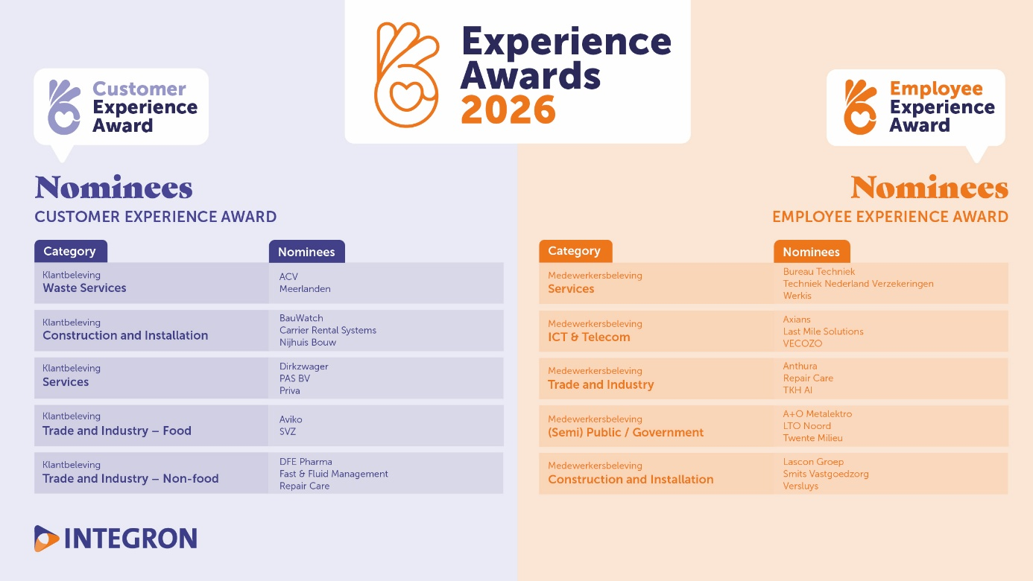

Nominees Customer Experience Awards
The Customer Experience Awards are divided into 5 categories and are based on customer surveys conducted by Integron for over 200 organizations in 2025. The nominations are based on the highest NPS scores within each category, reflecting the likelihood of customers recommending the organization.
Waste Services
- ACV
- Meerlanden
Construction and Installation
- BauWatch
- Carrier Rental Systems
- Nijhuis Bouw
Services
- Dirkzwager
- PAS BV
- Priva
Trade and Industry – Food
- Aviko
- SVZ
Trade and Industry – Non-food
- DFE Pharma
- Fast & Fluid Management
- Repair Care

Nominees Employee Experience Awards
The Employee Experience Awards are divided into 5 categories and are based on employee surveys conducted by Integron for over 150 organizations in 2025. The nominations are based on the highest eNPS scores within each category, reflecting the likelihood of employees recommending the organization as an employer.
Services
- Bureau Techniek
- Techniek Nederland Verzekeringen
- Werkis
ICT & Telecom
- Axians
- Last Mile Solutions
- VECOZO
Trade and Industry
- Anthura
- Repair Care
- TKH AI
(Semi) Public / Government
- A+O Metalektro
- LTO Noord
- Twente Milieu
Construction and Installation
- Lascon Groep
- Smits Vastgoedzorg
- Versluys

About the Experience Awards
This is the 16th time Integron presents the Experience Awards. More than 350 organizations have been nominated in the past, and over 110 organizations have received an award. The nominations are based on the average scores given by employees and customers.

About Integron
Happy People. That’s what drives us. We create impact through insight. With passion, enthusiasm, and enjoyment, we work together with our clients to achieve their strategic goals. Through our Employee Experience (EX) and Customer Experience (CX) feedback programs, we help organizations build happy employees, enthusiastic customers, and better business results.
www.integron.nl
#belevingawards2026

Note to editors, not for publication
For more information about the Experience Awards 2026 and Integron, please contact Daan Wuite, Marketing Manager at Integron, via phone +31 10 4115966 or email info@integron.nl.

